**SUTTON MIDDLE SCHOOL**

**ATHLETIC GUIDELINES**



**APRIL 2018**

**TABLE OF CONTENTS**

Atlanta Public School Athletics Overview 3

Sutton Middle School Mission, Objectives and Core Values 4

Sports Sponsorship by APS and SMS PTA 5

SMS Sports by Season 6

Sports Definition 7

Student Eligibility 7

SMS Athletics Leadership Structure 8

SMS Athletics Leadership Roles and Responsibilities 9

APS Athletic Director 9

PTA Athletic Director 11

PTA Vice President of Sports 13

PTA Sports Chairs 14

Team Parents 16

Head Coaches 17

Assistant Coaches 18

SMS Athletics Schedule 19

Forms 22

Branding 23

Budgeting and Team Fees 24

Scheduling 25

Communication 26

Tryouts 27

Transportation 29

Snacks and Concessions 29

Team Photos 29

New Sport Introduction 30

Issue Escalation 31

Intramural Sports 32

Facilities 33

**APPENDIX**

Sports Physical Form 34

Permission Slip 39

**ATLANTA PUBLIC SCHOOLS ATHLETIC OVERVIEW**

“The Department of Athletics offers a wide variety of interscholastic opportunities for our students.

It is our goal that all of our students get involved in our athletic program. There are so many lessons that can be gained from being a part of something bigger than yourself. There is a place for everyone. The qualities that can be learned include team work, dedication, desire, hard work and accomplishing things one never thought they could accomplish. Our responsibility to each of you is to provide the very best we can for each of our student-athletes.”

<https://www.atlantapublicschools.us/domain/216>

**SUTTON MIDDLE SCHOOL ATHLETICS MISSION**

Sutton Middle School Athletics will support the goal set forth by Atlanta Public Schools as it relates to sports. In addition, the PTA strives to supplement the sports program by offering additional sports and/or teams based on demand and to allow for individual skill development.

It shall be the philosophy of Sutton Middle School that athletes shall enjoy as many sport seasons as the student-athletes and their parents wish them to participate in without influence from any coach to specialize in one sport. All coaches should encourage participation in other sports.

**SUTTON MIDDLE SCHOOL ATHLETICS OBJECTIVES**

1. To create a sense of belonging and character development for all students
2. To demonstrate a stronger athletic presence/reputation in the community
3. To allow for individual skill development
4. To ensure continuity between Sutton Middle School and North Atlanta High School sports
5. To provide a strong intramural program for sixth graders
6. To allow for as many seventh and eighth graders as possible to play competitively for Sutton

**CORE VALUES**

The following core values guide the actions, decision-making and conduct of Sutton Middle School athletes, coaches and administrators.

* **Student-Athlete Experience** - We provide an environment that promotes personal, academic, athletic and social development.
* **Integrity** - We are honest and moral.
* **Excellence** - We maximize our efforts and talents to ensure student success.
* **Respect** - We value the importance of diversity, fairness, goodwill and sportsmanship.
* **Equity** - We strive to provide all students with the support and opportunity to succeed.
* **School Pride** - We support an atmosphere that embraces school spirit, honors tradition and develops our students.
* **School Engagement** - We are dedicated to integrating our activities into school activity so as to promote student connection with the school community and enhance their middle school experience.

**SPORTS SPONSORSHIP BY APS AND PTA**

Atlanta Public Schools sponsors five sports at the middle school level. APS funds these sports and provides guidance on their delivery. APS sports games are competitive with other middle schools and are available for 7th and 8th-graders only.

The Sutton Middle School PTA supplements these five sports with other offerings, both at the competitive level for 7th and 8th-graders, and at the intramural level for 6th-graders. The SMS PTA funds these sports and offers guidance on their delivery in this document. The PTA also supports and funds additional teams in the same sports that APS sponsors.

While the financial support for these teams comes from different sources, the delivery of the sports themselves should be consistent for parents and athletes. APS sports will be delivered in the same manner as PTA sports.

The offerings (subject to change) are as follows:

APS-sponsored sports

* Football
* Softball
* Basketball
* Cheerleading
* Soccer
* Track and Field

PTA-sponsored sports

* Volleyball
* Cross Country
* Tennis
* Ultimate Frisbee
* Wrestling
* Baseball
* Golf
* Lacrosse
* Additional basketball teams
* Additional soccer teams

Intramural sports

* Basketball
* Soccer
* Volleyball
* Fencing
* Yoga
* 5K training
* Conditioning

**SUTTON MIDDLE SCHOOL SPORTS BY SEASON**

FALL SPORTS

* Football, Boys
* Softball, Girls
* Soccer, Boys
* Volleyball, Girls
* Cross Country, Boys and Girls
* Football Cheerleading, Girls
* Tennis, Boys and Girls
* Ultimate Frisbee, Co-Ed

WINTER SPORTS

* Basketball, Boys and Girls
* Basketball Cheerleading, Girls
* Wrestling, Boys

SPRING SPORTS

* Track and Field, Boys and Girls
* Baseball, Boys
* Soccer, Boys and Girls
* Golf, Co-Ed
* Tennis, Boys and Girls
* Lacrosse, Boys and Girls

Sports can be organized on the “A” or “B” and 6-th grade team levels.

**SPORTS DEFINITION**

In order to be considered a sport at Sutton Middle School, the activity must have defined teams and compete against other teams. If a sport does not compete against other teams but is arranged purely for fun, community and athletic development, it is considered an intramural sport. Non-competitive dance teams are considered fine arts.

**STUDENT ELIGIBILITY**

Sutton Middle School athletics are open to all students. The requirements for participation are as follows:

* Students must attend Sutton Middle School.
* Students must have passed five of seven classes in the prior semester.
* Students must be in 7th or 8th grade to participate on competitive teams.
* 6th graders may participate on 6th-grade specific teams or in intramural sports.
* 6th graders may participate in competitive sports only if there are not enough 7th and 8th graders to field a team. This will be determination will be made by the PTA Board (I don’t think this should be a board decision; it should be athletic director) after tryouts have been completed.
* Students may not have reached their 16th birthday.

**SMS ATHLETICS LEADERSHIP STRUCTURE**

The leadership for the Sutton Middle School Athletics program is a partnership between SMS staff and dedicated PTA volunteers. The principal and all of the athletic directors are SMS staff members. The VP of sports and the three PTA chairs are volunteers. The structure for leadership positions is outlined below. The roles and responsibilities for each position follow.

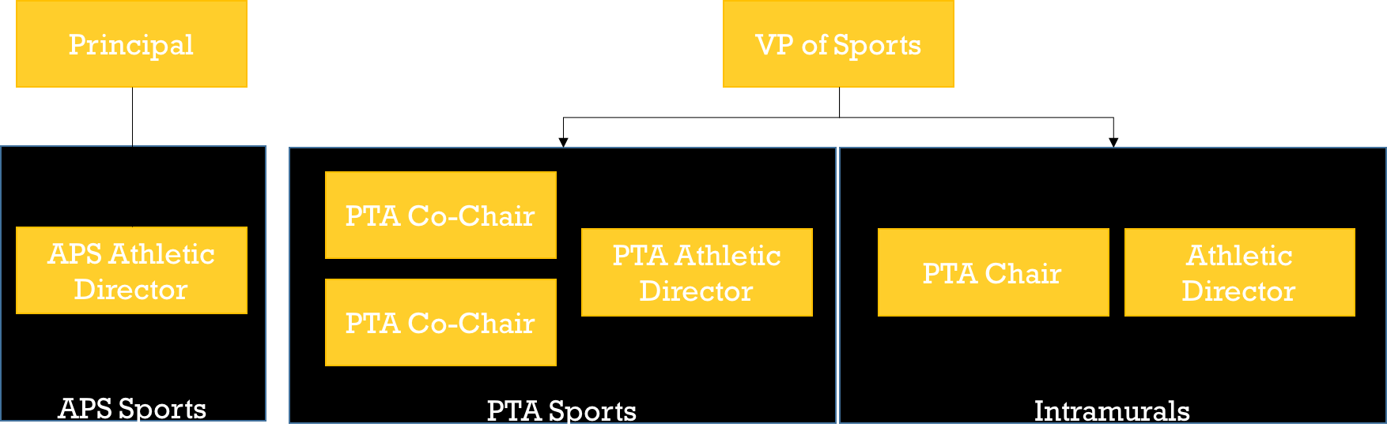

**APS SPORTS ATHLETIC DIRECTOR RESPONSIBILITIES**

The APS athletic director is a Sutton Middle School staff member hired by APS to run the athletic department for APS sports at the school. In addition to the roles and duties of running APS sports, this person will be the liaison to PTA sports in order to ensure consistency and adherence to school policies across the entire sports program. This APS Athletic Director will adhere to all timelines and policies in addition to performing the following duties. Responsibilities are as follows:

Communication

* Implement a regular meeting cadencebetween the APS and PTA sports leadership positions (ADs, VP, Chairs). Meetings should take place at the beginning, middle and end of each sports season.
* Ensure all coaches and team parents are utilizing Team Snap as their primary method of communication (i.e. rosters, schedules, changes in schedule, etc.).

Scheduling

* Create and communicate the master scheduleof all APS sports tryout dates to the PTA in the spring for the upcoming school year.
* Create and communicate the master scheduleof practices and games for APS sports to the PTA.
* Communicate try out dates and time to the school newsletter ([suttonsource@gmail.com](mailto:suttonsource@gmail.com)) with as much notice as possible.
* Obtain all necessary referees, umpires, etc.and communicate with them if inclement weather cancels an event.

Field Space

* Manage the use of field space and facilitiesat both campuses. Coordinate with the PTA AD and Intramural AD to ensure field space is provided to the following sports teams in this order of priority:
  + APS sport teams
  + PTA sports teams
  + PTA Intramurals
  + Partners (i.e. Northside Methodist, Buckhead Baseball, NYO, Top Hat, Surge, and possibly others at the discretion of the Athletic Director.).
* Work with the PTA to secure donations (monetary or in-kind) for usage of facilities) from partners.
* Work with the Assistant Principal to keep the master schedule.

Forms

* + Require every student trying out for a sport to provide a copy of a physical and permission slip. Require these with every tryout rather than relying on those already on file.
  + Collect and keep a master list of forms by athlete.
  + Ensure all community coaches have a current APS background checkcompleted prior to the start of the season.
  + Ensure all coaches have completed a signed coach’s agreement.

Funding

* Require all coaches and team parents to communicate the team fee of $35 per season for each APS sport played.
* Funds should all be collected online via the use of the PTA Online Store. Coordinate with the PTA treasurers if there are changes to the team fee. ([suttonptatreasurer@gmail.com](mailto:suttonptatreasurer@gmail.com))

Other

* Hire coaches as needed. Coaches should be secured the spring of the preceding year, or at a minimum, one month prior to try outs.
* Check for students' academic eligibility for participation in sports at SMS.
* Collect all balls, equipment and uniforms from coaches at the end of the season (I think the PTA AD does this for PTA sports).
* Work with PTA VP of Sports to resolve any issues escalated by the ADs and PTA Chairs.
* Ensure the PTA ADs are aware of school policies and changes to them.

**PTA ATHLETIC DIRECTOR RESPONSIBILITIES**

The PTA athletic director is hired by the PTA and is paid a stipend to run all PTA sports offered at Sutton. In addition to the roles and duties of running PTA sports, this person will be the liaison to APS sports in order to ensure consistency and adherence to school policies across the entire sports program. This PTA athletic director will adhere to all timelines and policies in addition to performing the following duties:

Communication

* Implement a regular meeting cadencebetween the APS and PTA sports leadership positions (ADs, VP, Chairs). Meeting should take place at the beginning, middle and end of each sports season.

Scheduling

* + Hire coachesfor the PTA sponsored sports teams. Coaches should be secured during spring of the preceding year, or at a minimum, one month before tryouts begin.
  + Create and communicate the master scheduleof all PTA sports tryout dates in the spring for the upcoming school year.
  + Communicate try out dates and time to the school newsletter ([suttonsource@gmail.com](mailto:suttonsource@gmail.com)) with as much notice as possible.
  + Create and communicate the master scheduleof practices and games. Be on call for games and practices.
  + Obtain all necessary referees, umpires, etc.and communicate with them if inclement weather cancels an event.
  + Work with the APS AD to secure and manage field space and facilitiesfor all PTA sports teams.

Forms

* + Require every student trying out for a sport to provide a copy of a physical and permission slip, regardless of any prior forms on file. Collect and submit the required athlete documents to the APS AD within two weeks of the activity’s start.
  + Ensure all community coaches have a current APS background checkcompleted prior to the start of the season. Also, ensure they submit a tax form.
  + Ensure all coaches have completed a signed coach’s agreement.
  + Submit Facility Use Form for all teams.

Funding

* + Require all coaches and team parents to communicate and collect fees for each PTA sport played. Funds should all be collected online via the PTA Online Store. Coordinate with the PTA treasurers if/when fees need to change (suttonptatreasurer@gmail.com).
  + Submit the budgets (planned stipends, expenses and revenue) for all PTA sponsored sports to the PTA in the spring of the year preceding the next school year.
  + At the start of each sport season, verify that the coaches have setup Team Snap (rosters, schedule, etc.) as the method of communication during the season.
  + At the conclusion of the season, verify that the coaches have done the following before requested payment of a coach’s stipend:
    - Performed his/her duties as coach successfully
    - Attended regularly scheduled practices and games
    - Returned all uniforms and equipment
    - Reported the condition of all sports equipment and uniforms to the AD in case new items are needed.
    - Reported team results.
* Other
  + Check for students' academic eligibility for participation in sports at Sutton.
  + Order any team t-shirts/uniforms that are included in the activity fee.
  + Collect all uniforms, balls and equipment from coaches at the end of the season.
  + Escalate unresolved issues to the VP of Sports.

**PTA VICE PRESIDENT OF SPORTS RESPONSIBILITIES**

The VP of Sports position is a self-and/or peer nominated position that is ultimately voted on and confirmed via the PTA at a general meeting. The responsibilities of the VP of Sports are as follows:

Communication

* Implement a regular meeting cadencebetween the APS and PTA sports leadership positions (ADs, VP, Chairs). Meetings should take place at the beginning, middle and end of each sports season.
* Ensure the Sutton website is kept up-to-date

Funding

* Prepare budgets(estimated stipends, expenses and revenue by team) for all PTA sports in the spring prior to the upcoming school year. Get input from athletic directors and PTA chairs.
* Review revenue and expenditures by team on a monthly basis. Report to the PTA Board each month. Work with the ADs, chairs, coaches and team parents to resolve any deviations.
* Request stipend payments for coaches upon successful completion of the season and upon receipt of summary of season (i.e. # of games played, results, etc.).
* Work with the APS AD to review and revise donations from partners where necessary.

Other

* Ensure all of the PTA sports positions (ADs, chairs, coaches, team parents) are performing their responsibilitiesand are abiding by the guidelines.
* Ensure consistencyacross all sports teams.
* Where appropriate, incorporate partnershipsinto the program.
* Coordinate with the North Atlanta High School Sports Programto ensure consistency and to identify synergies between the programs.
* Communicate opportunities and results to feeder elementary schools. Expose parents and students at feeder schools to sports opportunities at Sutton. Expose Sutton parents to opportunities at North Atlanta.
* Evaluate requests for new (or retiring) sports teams and present recommendations to the PTA Board for approval.
* Evaluate and provide recommendations to the PTA board on any policy changes.
* Promote sports at the ‘We Are Sutton’ and ‘Celebration of Learning’ events, as well as any other applicable school events.

**PTA SPORTS CHAIR RESPONSIBILITIES**

PTA Sports Chair responsibilities will be divided by sport each season. Each chair will have responsibility for specific sports. These same duties will be handled by the Intramural sports chair for intramural sports. Responsibilities include:

Team Parent Liaison

* Act as team parent liaison.
* Ensure all teams have a team parent, that they have received a copy of the team parent responsibilities and that they understand them.

Team Snap

* Ensure that all team parents have set up rosters and schedules in Team Snap. Assist with set up where needed.
* Ensure that all teams are utilizing Team Snap for communication, especially with regard to last minute weather delays or changes. Assist where needed.

Budget

* Ensure that team fees have been loaded into the PTA Online Store (Square).
* Ensure that teams are collecting fees from players.
* Assist with obtaining scholarships where needed. (this needs explaining)
* Assist AD with calculating any budget changes for the upcoming year.

Tryouts

* The PTA Chairs will be responsible to distributing tryout information in the Sutton Source, and website each season. Tryout information will include:
* List of necessary APS and PTA forms, releases, etc. and how to access them electronically. Remind parents that their child needs to bring forms with them regardless of whether they have submitted them before.
* Tryout dates with start times and end times
* Where the students need to meet for the tryouts and any necessary equipment they should bring
* Pickup location for parents
* Time commitment for athletes including duration of season, practice schedule, and number of games
* Amount of Activity Fee
* Number of spots on the team
* When and where they can expect the rosters to be posted

Every sport tryout will include a signup sheet for each student trying out. The PTA Chairs will distribute the forms to the coaches prior to tryouts. The signup sheet will include at least:

* Student's Full Name
* Student's Tryout Number
* Grade Level
* Parent's email address
* Parent's phone number
* Any other information the coach deems necessary prior to tryouts

Team Information Packet

PTA Chairs will assist their coaches in creating the information packet for distribution at the parent meeting. The information will include the following:

* Practice days and times
* Game schedule if it is available
* Any uniform requirements
* Team parent contact information
* Coach's contact information
* Amount of the activity fee (Team Parents will collect the fees and give them to the appropriate Athletic Director)
* The procedure for riding busses to away games for APS sports
* The fact that parents are responsible for getting students to away games for PTA sports
* Any additional information specific to your sport

**TEAM PARENT RESPONSIBILITIES**

Each sport will have a team parent to assist with the facilitation of the team. Responsibilities include:

Communication

* As soon as the team is set, obtain a full roster and contact information from the coach.
* Enter all rosters and contact information into Team Snap. Ask sports chairs to assist, if needed. Ensure the athletic directors and PTA sports chairs are included on all Team Snap rosters.
* Send invitations to parents via Team Snap.
* Utilize Team Snap for all team communication via the messages tab.
* Introduce yourself to the team as the team parent.
* Make sure that you have all coaches' cell phone numbers and they have yours.
* Assist the coaches in communicating to the parents. This could include reminders, changes to games or practices, bringing snacks or drinks for the kids, arranging rides to away games for PTA sports, etc. Utilize the messages tab in Team Snap for all communication.
* Send weekly communication to Sutton Source regarding game outcomes, upcoming playoffs and tournaments etc. Be sure to include photos where possible. Copy the athletic director and PTA chair on your email to suttonsource@gmail.com.

Budget

* Remind parents to pay all team fees via the PTA Online Store at the beginning of season.
* Track down parents who have outstanding fees.
* Work with parents and PTA chair on obtaining scholarships where needed.

Photographs

* Ensure the team is informed about upcoming team photographs.
* Solicit candid team photos from the team and submit them to the yearbook editor and Sutton Source editor. Please note that the deadline for submission of pictures for the yearbook is usually in early March. If you are assisting with a spring sport, please make sure you submit some candid photos very early in the season.

Transportation

* Coordinate carpool for away games, if PTA sport. APS sports use school buses. Utilize Sign Up Genius to solicit parent volunteers.

Snacks

* Coordinate snacks for games where needed. Utilize Sign Up Genius to solicit parent volunteers.
* Ask PTA chair for assistance, if needed.

**HEAD COACH AND ASSISTANT COACH RESPONSIBILITIES**

**HEAD COACH RESPONSIBILITIES**

The coach’s first and foremost responsibility is to develop student athletes and promote the team through athletics. The coach is the player’s first contact and should see themselves as a mentor and teacher to his or her players.

Coaches are hired by the athletic directors. When a coaching position becomes available, athletic directors may send a blast to Sutton faculty and staff asking if they are interested in the position. The athletic directors may also hire coaches directly from the community. The athletic directors, VP of Sports and Sports Chairs will interview prospective coaches and collectively make a decision about the final candidate.

Once hired, all coaches must have the following forms in place to coach at Sutton Middle School:

* APS background check that is current within the last five years
* Signed coach’s agreement
* IRS Form W-9

Coaches are responsible for the following:

* Selecting the players for the team
* Determining player assignments on the team
* Running practices
* Developing lineups and rotation schedules for games
* Holding a parents meeting at the beginning of the season to set expectations. With assistance from the PTA Chair, an information packet should be distributed that contains the following:
* Practice days and times
* Game schedule if it is available
* Any uniform requirements
* Team parent contact information
* Coach's contact information
* Amount of the activity fee (Team Parents will collect the fees and give them to the appropriate Athletic Director)
* The procedure for riding busses to away games for APS sports
* The fact that parents are responsible for getting students to away games for PTA sports
* Any additional information specific to your sport
* Distributing and collecting signed copies of the student athlete agreement from his or her players.
* Selecting a team parent to support the team
* Providing the roster and contact information to the team parent for Team Snap
* Communicating any schedule changes to the team parent for communication to the team
* Providing feedback to players to help improve their performance
* Being knowledgeable of all league rules and regulations
* Using self-control in all instances
* Teaching players good sportsmanship
* Encouraging players to work together to improve performance
* Keeping track of all balls, equipment and uniforms and turning them in to the athletic director at the end of the season
* Being ultimately responsible for the welfare of the children when playing the sport
* Ensuring all students are picked up at the end of each practice and game

**ASSISTANT COACH RESPONSIBILITIES**

All assistant coaches must have the following forms in place to coach at Sutton Middle School:

* APS background check that is current within the last five years
* Signed coach’s agreement
* Tax form

Assistant coaches are responsible for the following:

* Assisting the head coach in any and all of his responsibilities
* Running games and practices when the head coach is not available
* Providing feedback to players to help improve their performance
* Encouraging players to work together to improve performance
* Being ultimately responsible for the welfare of the children when playing the sport
* Using self-control in all instances
* Teaching players good sportsmanship
* Being knowledgeable of all league rules and regulations

**SMS ATHLETICS SCHEDULE**

The SMS athletics leadership team will utilize the following schedule for its planning purposes. By adhering to this schedule the leadership will plan ahead and minimize the need for many last minute changes. The schedule is as follows:

**January**

* Begin spring sports tryouts - Coaches
  + Baseball
  + Boys and girls track
  + Boys’ and girls’ soccer
  + Boys’ and girls’ lacrosse
  + Boys and girls golf
  + Boys’ and girls’ tennis
* Hold spring sports team meetings and distribute packet – Coaches and PTA Chairs
* Begin spring sports practices and games – Coaches
* When teams are selected, reach out to team parents to assist with Team Snap and collect fees – PTA Chairs
* Load rosters and schedules into Team Snap – Team Parents
* Identify PTA Co-Chairs for the next year- PTA VP

**February**

* Finalize expenditures for winter sports – ADs
* Ensure fees are being collected for spring sports – VP of Sports
* Schedule team photos for yearbook – PTA Sports Chairs and Yearbook Chair

**March**

* Ensure fees are being collected for spring sports – VP of Sports

**April**

* Finalize expenditures for Spring Sports – ADs
* Finalize comprehensive PTA Sports budget for the upcoming year – ADs, VP of Sports, Sports Chairs and Treasurer
* Secure all coaches and field space for fall sports – ADs
* Secure sports chairs for upcoming year – VP of Sports

**May**

* Submit final budget to PTA for upcoming year and gain approval – ADs and VP of Sports
* Approve budget for upcoming year – PTA Board
* Set calendar for upcoming school year – VP of Sports, Chairs and ADs
  + Celebration of Learning
  + Tryout dates
  + Parent meetings
  + Homecoming activities
* Revise any documentation and file all documents for new chairs – PTA Chairs

**June**

**July**

* Update all forms for Celebration of Learning – PTA Chairs with ADs
  + Sports policies
  + List of sports
  + Physical forms
  + Permission slips
  + Intramurals information
  + Sports calendars
  + Fall sports tryout dates
* Update website for all sports fees for the year - ADs
* Update website as needed – Ads
* Announce fall sports tryouts in Source – PTA Chairs

**August**

* Announce fall sports tryouts in Source – PTA Chairs
* Begin fall sports tryouts - Coaches
* Begin fall sports practices and games - Coaches
  + Football
  + Boys soccer
  + Girls softball
  + Cross country
  + Girls volleyball
  + Football cheerleading
  + Boys’ and girls’ tennis
  + Ultimate Frisbee
* Hold team meetings and distribute packet – Coaches and PTA Chairs
* Begin practices and games – Coaches
* When teams are selected, reach out to team parents to assist with Team Snap and collect fees – PTA Chairs
* Load rosters and schedules into Team Snap – Team Parents

S**eptember**

* Ensure all teams are collecting fees – VP of Sports
* Finalize coaches and field/court space for winter sports - ADs
* Announce winter sports tryouts in Source – PTA Chairs
* Schedule team photos for yearbook – PTA chairs and Yearbook Chair

**October**

* Secure insurance for basketball, if necessary
* Begin winter sports tryouts - Coaches
  + Boys and Girls Basketball
  + Basketball cheerleading
  + Wrestling
* Finalize expenditures for fall sports – ADs
* Hold team meetings and distribute packet – Coaches and PTA Chairs
* Begin practices and games – Coaches
* When teams are selected, reach out to team parents to assist with Team Snap and collect fees – PTA Chairs
* Load rosters and schedules into Team Snap – Team Parents

**November**

* Begin winter sports practices and games – Coaches
* Schedule team photo for yearbook – PTA Chairs and Yearbook Chair
* Finalize coaches and field space for spring sports – ADs
* Ensure all teams are collecting fees – VP of Sports

**December**

* Announce spring sports tryouts in Source – PTA Chairs

**FORMS**

The following forms must be collected by the identified individuals each season. Forms must be kept on file by the athletic directors.

|  |  |  |  |
| --- | --- | --- | --- |
| **FORM** | **SUBMITTED BY** | **HOW SUBMITTED** | **KEPT BY** |
| [PTA permission slip](https://www.atlantapublicschools.us/cms/lib/GA01000924/Centricity/Domain/7297/SMSIntramuralPTAPermissionForm.pdf) | Student athlete | Hard copy at first day of tryouts | ADs and coach |
| [Sports physical](https://www.atlantapublicschools.us/cms/lib/GA01000924/Centricity/Domain/7297/APSphysicalform.pdf) | Student athlete | Hard copy at first day of tryouts | ADs and coach |
| Copy of insurance card or sports insurance | Student athlete | Hard copy at first day of tryouts | ADs and coach |
| Players agreement | Student athlete | Hard copy | ADs |
| Coach’s agreement | Head coaches and assistant coaches | Hard copy | ADs |
| APS background check | Head coaches and assistant coaches | Hard copy | ADs |
| IRS Form W-9 | Head coaches and assistant coaches | Hard copy | PTA Treasurer |
| Field use form | PTA AD | Hard copy | APS AD |

**BRANDING**

All team uniforms, signage and other materials must meet Sutton Middle School and Atlanta Public Schools branding guidelines. The guidelines are outlined [here](https://www.atlantapublicschools.us/domain/8842).

The ADs will adhere to these guidelines as they order uniforms and equipment for the teams. The PTA Chairs will work with their team parents to ensure any signage or other materials meets the guidelines.

**BUDGETING AND TEAM FEES**

All SMS athletes will pay team fees for participation in sports. All PTA-supported sports must be self-funded. PTA sports fees are determined by expenditures from the prior year divided by the estimated number of students, based on the prior year. While APS sports are funded by APS, athletes participating in an APS-supported sport will pay a $35 sports fee to help offset the expenses associated with sports. If APS teams participate in PTA sponsored games (e.g., soccer), they will pay an additional fee.

All athletes are expected to pay team fees. Students will not be prohibited from playing sports if their families cannot afford to pay sports fees. Instead, families will be asked to contribute an amount of their choosing to the PTA to offset sports fees. The PTA will then contribute a scholarship for that athlete, less the amount paid by the athlete. The PTA Treasurer will track the number and amount of scholarships distributed and account for them in the budget.

The PTA budget for the year will be finalized in April of the preceding year. The Treasurer will work with the ADs, VP of Sports and PTA Chairs to finalize the budget. Team fees will be set at based on player numbers from the prior year. A proposed budget for the upcoming year will be presented to the PTA Board for approval in its May meeting. Any unexpected expenses should be brought to the PTA Treasurer.

The process for budgeting and team fees will be as follows:

April

* The overall PTA sports budget is finalized by ADs, VP of Sports, Sports Chairs and Treasurer.
* Team fees are set are set based on current year numbers by ADs, VP of Sports, Sports Chairs and Treasurer.

May

* Final budget and team fees are presented to the PTA Board for approval.

Each season

* Team fees are loaded into the Sutton Middle School PTA Online Store by the Treasurer available on the SMS website.
* Team fees will be communicated to parents in advance of tryouts as well as the 10-day collection timeframe, as much as possible.
* Team parents communicate with parents to pay team fees.
* Parents pay team fees online via PTA Online Store. If parents cannot pay online (i.e. no credit card) they can submit a check payable to SMS PTA to the Athletic Director.
* VP of Sports tracks payment of fees and reports to the PTA Board on a monthly basis. Fees should be reported by team so that team parents and others can easily determine outstanding fees so they can collect them.
* Team fees must be paid within 10 days of the team’s announcement. If a family has not paid team fees at that time, the AD will contact them and ask them if they need financial assistance. At that time, they must either pay the dues or request financial assistance via scholarship. If fees are still not paid, their child may not participate in the sport.
* Team parents and PTA Sports Chairs work with parents to collect all fees.
* Team parents and PTA Chairs will assist in obtaining scholarships for athletes, where needed.
* At the end of the season, all expenditures are communicated by the Athletic Director to Treasurer for payment, including stipend payment for coaches and assistant coaches.
* At the end of each semester, the PTA Treasurer, the VP of Sports and the Athletic Directors will conduct a budget review.
* Athletic Directors make budgetary requests for teams for upcoming year (i.e. equipment, uniforms etc.)
* Treasurer updates the budget for the upcoming year based on number of participants and new requests.

**SCHEDULING**

A dedicated master sports calendar will be maintained and accessible to the entire Sutton Community via the Sutton website or directly through this link (https://calendar.google.com/calendar/embed?src=afielder%40apsk12.org&ctz=America%2FNew_York). This calendar will list all finalized practices, tryout dates/times, home and away games, picture days etc. for every Sutton sport being played at both Sutton campuses.

The master sports schedule will be set by May of the preceding year. The calendar will include:

* Celebration of Learning
* Tryouts for all sports
* Tentative schedule for team play (e.g. mid-February through mid-April, exact dates TBD)
* Homecoming activities
* Others

The master calendar will be approved by the PTA Board during the May meeting. It will be distributed to prospective parents during the Celebration of Learning.

During the year, the APS AD will maintain a master sports calendar to include all practices and games across both APS and PTA sports. The AD will have responsibility for communicating the master calendar to the PTA AD, VP of Sports and Sports Chairs.

**FIELDS AND FACILITIES**

The APS AD will work with an assistant principal to maintain a master calendar of field and facilities use. This calendar will include not only Sutton APS and PTA sports, but also use of fields and facilities by partners. Fields and facilities requests will be honored in the following order:

1. APS sports
2. PTA sports
3. Intramural sports
4. Partners

Fields and facilities will take into account in-kind and monetary donations from partners when scheduling fields and facilities.

**COMMUNICATION**

Team Snap will be Sutton Middle School’s primary vehicle for communication. The school purchased a League membership to accommodate the many sports schedules for Sutton students. The communication process is as follows:

* The APS AD, PTA AD, VP of Sports and Sports Chairs will meet three times during each season – at the beginning, middle and end. They will review and discuss any progress, the collection of fees, and any issues. The VP of Sports will update the PTA Board during the regular monthly meetings.
* The Athletic directors will hold a coaches meeting at the beginning of each season to set expectations around responsibilities, procedures, communication and fees.
* Coaches will hold a parents meeting at the beginning of each season. They will set expectations around practices and games, playing time, transportation, communication, fees and issues. The team must select a team parent during this meeting.
* Team parents will establish team rosters, practices and schedules in Team Snap.
* Team parents will send a welcome email to their teams introducing themselves, reminding parents to pay team fees (link to payment portal to be included in email), asking for assistance where needed including transportation to and from away games, snacks, keeping clocks and statistics, and working the concession stand.
* Team parents set up a Sign Up Genius to assist with sign ups.
* Team parents and coaches communicate to teams through Team Snap throughout the season.

If there are schedule changes, the protocol is as follows:

* The League communicates with the ADs
* The ADs communicate to coaches, team parents, the Sutton Source editor and front office
* The team parent sends out communication via team snap
* If the change occurs in the same day (as in the case of inclement weather), the Sutton Source editor sends out an email blast and the team parent communicates via Team Snap

**TRYOUTS**

The master schedule for all sport tryouts will be created during the spring of the year preceding the next school year. Considerations will be given to which sports will still be underway when the schedules are established.

Any changes to tryout dates and times will be finalized by the deadlines listed below:

* For winter sports the tryout information should be? will be finalized by? no later than September 15th.
* For spring sports, the tryout information will be finalized no later than November 15th.
* For fall sports the tryout information will be finalized no later than May 15th.

Comprehensive tryout information will be posted in multiple places: Sutton Source, Sutton website, and posted flyers, NO LATER THAN ONE MONTH before tryouts start. These tryout dates and times may not be changed, extended, or canceled once posted except in the case of inclement weather or school closings.

The PTA Chairs will be responsible to distributing tryout information in the sources listed above each season. Tryout information will include:

* List of necessary APS and PTA forms, releases, etc. and how to access them electronically. Remind parents that their child needs to bring forms with them regardless of whether they have submitted them before.
* Tryout dates with start times and end times
* Where the students need to meet for the tryouts and any necessary equipment they should bring
* Pickup location for parents
* Time commitment for athletes including duration of season, practice schedule, and number of games
* Amount of Activity Fee
* Approximate Number of spots on the team
* When and where they can expect the rosters to be posted

Every sport tryout will include a signup sheet for each student trying out. The PTA Chairs will distribute the forms to the coaches prior to tryouts. The signup sheet will include at least:

* Student's Full Name
* Student's Tryout Number
* Grade Level
* Parent's email address
* Parent's phone number
* Any other information the coach deems necessary prior to tryouts

While the format of the tryout is up to the coach’s discretion, there are some policies which all coaches should? must adhere to. They are:

* Players must have hard copies of their physical forms and permission slips to try out, regardless of whether they have submitted them in the past.
* Tryouts should last no longer than one week.
* Coaches should consider all aspects of performance before eliminating players.
* Make-ups should be held for those who are ill, playing other sports or have other reasons for not attending the first day of tryouts.
* Players who are not in touch with the coach prior to the first day of tryouts and miss the first day are not eligible to try out.
* The team roster should be posted rather than eliminating players during tryouts. Team roster may be posted by assigning athletes a tryout number so the whole school does not need to see who made and did not make the team.

All rosters will be posted at the school in at least two locations by 3:00pm the DAY AFTER tryouts are finished. A copy of those rosters with tryout numbers coordinated to student names will also be given to the appropriate Athletic Director by 3:00pm the day after tryouts are finished. The roster should be emailed to the PTA Communications VP and/or PTA Sports Liaison for posting on the website.

Once a team is formed, either a team parent meeting or an information packet will be given to all students and their parents participating in a Sutton sport during the first week of practice. This information will include:

* Practice days and times
* Game schedule if it is available
* Any uniform requirements
* Team parent contact information
* Coach's contact information
* Amount of the activity fee (Team Parents will collect the fees and give them to the appropriate Athletic Director)
* The procedure for riding busses to away games for APS sports
* The fact that parents are responsible for getting students to away games for PTA sports
* Any additional information specific to your sport

**TRANSPORATION**

Transportation to and from APS-sponsored teams will be managed by Sutton Middle School. Athletes will travel to away games on a school bus. Parents may bring their child home from away games, but they must let the coach know before they go home.

Transportation to and from away games for PTA-sponsored teams will be managed by team parents. Team parents should utilize Sign Up Genius to secure enough drivers to and from away games. Parents may bring their child home from away games, but they must let the coach and/or parent drivers know before they go home.

**SNACKS AND CONCESSIONS**

Snacks and drinks before games are always welcome to sustain Sutton athletes and help them achieve top athletic performance. Team parents should utilize Sign Up Genius to ensure snacks are covered before games. Athletes should plan for their own snacks and drinks before and during practices.

Snacks should be healthy and substantial, and not include food or drinks that could cause athletes to feel sluggish. Sandwiches, crackers, fruit, and protein bars are good choices. Gatorade, PowerAde and water are good choices for drinks.

Sutton Middle School is pleased to have a concession stand available during home games during some sports such as basketball. The Athletic Directors are responsible for keeping concessions stocked and available for purchase. The Athletic Directors are also responsible for providing petty cash for the concession stand. Team parents can utilize Team Snap to have families assist in operating the concession stand during home games. The ADs will show parents how to operate the concession stand and collect cash at the end of the game. The ADs will submit funds to the Treasurer.

**TEAM PHOTOS**

Each team will have a set day for a team photo for the yearbook. At that time, families may have the option of purchasing individual photos as well. The team photo day will be established as a part of the master sports calendar. The yearbook and individual photos will be coordinated with the yearbook editor and the PTA Yearbook chair.

**NEW SPORT INTRODUCTION**

While Sutton offers a full complement of offerings for its students, there may be times where there is a proposal for the addition of a new sport. In those instances, the following must happen:

* The proposal should be made in advance of the sport’s season. For competitive sports, introductions should be made one year in advance. For intramural sports, introductions should be made six months in advance.
* The parent must be willing to do the following:
  + Coordinate with the appropriate league
  + Assist in finding community or faculty coaches
  + Assist in securing field space for both games and practices
  + Help with promoting the sport to ensure enough players to field a team (typically 10-15 players)
* The parent presents a written proposal to the VP of Sports. The proposal must include justifications for the items above.
* The VP of Sports discusses the proposals with the ADs. The introduction of the new sport is subject to Athletic Director approval.
* The VP of Sports and ADs make a recommendation to the PTA Board.
* The PTA Board votes on its approval.

Once a sport has been approved to inclusion in the SMS offerings, it will follow the protocol of the other sports in its season, as outlined above.

After the PTA Board has approved the new sport, it is the responsibility of the PTA AD to secure the coach(es) for the team and to include it in all scheduling.

**ISSUE ESCALATION**

Issues should be expected to arise during any sports season. The appropriate means for escalating issues is as follows:

* Parents should present any team-specific questions or issues about how a team is run, how decisions are made, playing time etc. to the coach. The coach will handle as necessary.
* If a coach needs additional assistance, he or she will escalate the issue to the athletic director.
* Parents should express any concerns about a coach to the athletic director.
* Athletic directors will handle the issues directly. If the situation warrants staff inclusion, the athletic directors will include the principal as they deem necessary.
* Concerns about PTA chairs should be directed to the PTA presidents. The PTA Board will ultimately determine direction on concerns around any PTA member.
* Concerns about the PTA AD should be directed to the Vice President of Sports. The PTA Board will ultimately determine direction on concerns around the PTA AD.
* Concerns about the APS AD should be directed to the principal. The principal will determine direction on concerns around the APS AD.

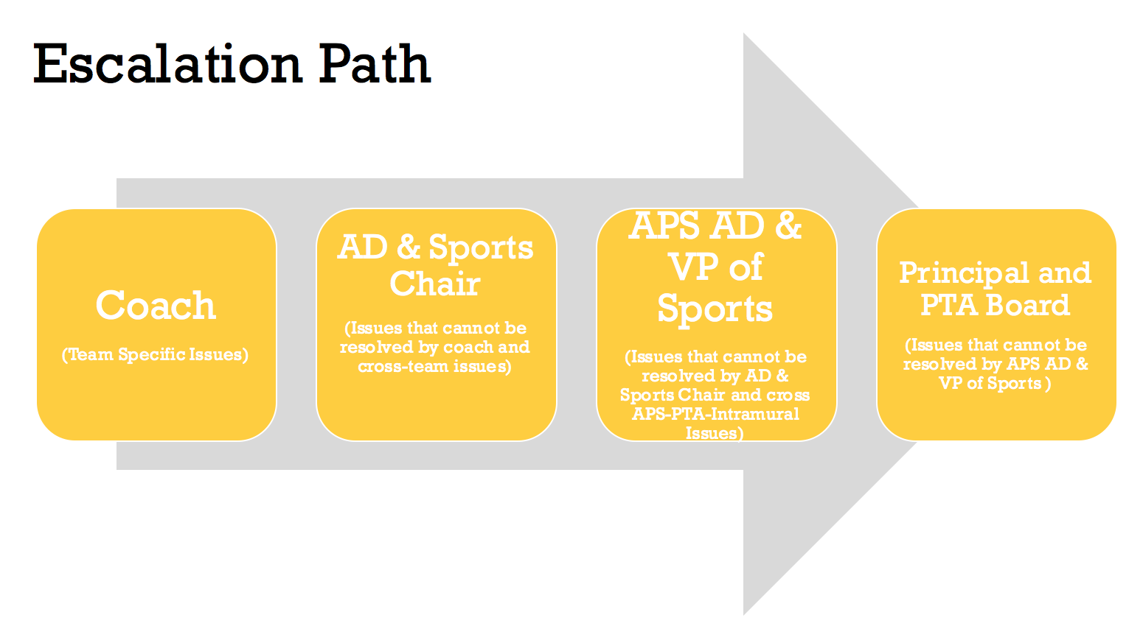

**INTRAMURAL SPORTS**

Sixth graders will be allowed to participate in all intramural sports offered at Sutton. All students in all grade levels are allowed to participate in intramural sports.

All intramural practices, scrimmages, etc. will be listed in the Master Sports Calendar along with the competitive sports.

All of the time commitments for practices, necessary equipment, activity fees, length of season, number of spots on the team, etc. for each intramural sport will be posted on the sports page of the Sutton website and modified as needed.

Each intramural sport offered at Sutton must have the coaches lined up in the spring of the year preceding the next school year. We will not offer a sport without a coach already signed on.

Each intramural sport offered at Sutton must have their budget submitted to the PTA in the spring of the year preceding the next school year.

No new intramural sports may be added during the school year. All requests for additional sport teams may be made in the spring of the year preceding the next school year.

A draft of the schedules for all intramural sport start and end dates will be created during the spring of the year preceding the next school year.

Comprehensive intramural information will be posted in all places: Sutton Source, Sutton website, and posted flyers, NO LATER THAN ONE MONTH before start date. These start dates and times may not be changed, extended, or canceled once posted except in the case of inclement weather or school closings.

Intramural sports information should include:

* List of necessary APS and PTA forms, releases, etc. and how to access them electronically
* Intramural sport start date with start times and end times
* Where the students need to meet for practice and any necessary equipment they should bring
* Pickup location for parents
* Time commitment including duration of season and practice schedule
* Amount of Activity Fee
* Number of spots on the team

Every intramural sport will include a signup either electronically via SignUp Genius (or similar) or on paper. The signup sheet will include at least:

* Student's Full Name
* Grade Level
* Parent's email address
* Parent's phone number

**FACILITIES**

Use of Sutton Middle School facilities – athletic fields and gym space – will be managed by an assistant principal. In addition to scheduling space, the assistant principal will also manage relationships and contracts with third-parties such as NYO, Buckhead Baseball and Top Hat. All agreements must include language that partners understand that Atlanta Public Schools has the right to change all agreements at any time. Changes made by APS will override any existing agreements with partners.

Every attempt should be made to allow the submission of all sports related forms to be done electronically. All paperwork that is not submitted electronically prior to the first practice will be brought on the FIRST DAY of practice, not before, allowing for one collection point of forms. If a child does not have his/her forms, they will not be allowed to participate.

If a cancellation of a practice is necessary due to inclement weather or conflict the coach will contact the team parent to distribute that information to parents as soon as possible.

Once an intramural sport begins, the coach will hold a parent meeting. The coach will distribute information regarding the sport including the following:

* Practice days and times
* Any uniform requirements
* Team parent contact information
* Coach's contact information
* Amount of the activity fee
* Any additional information specific to the sport

Appendix A – Sports Physical

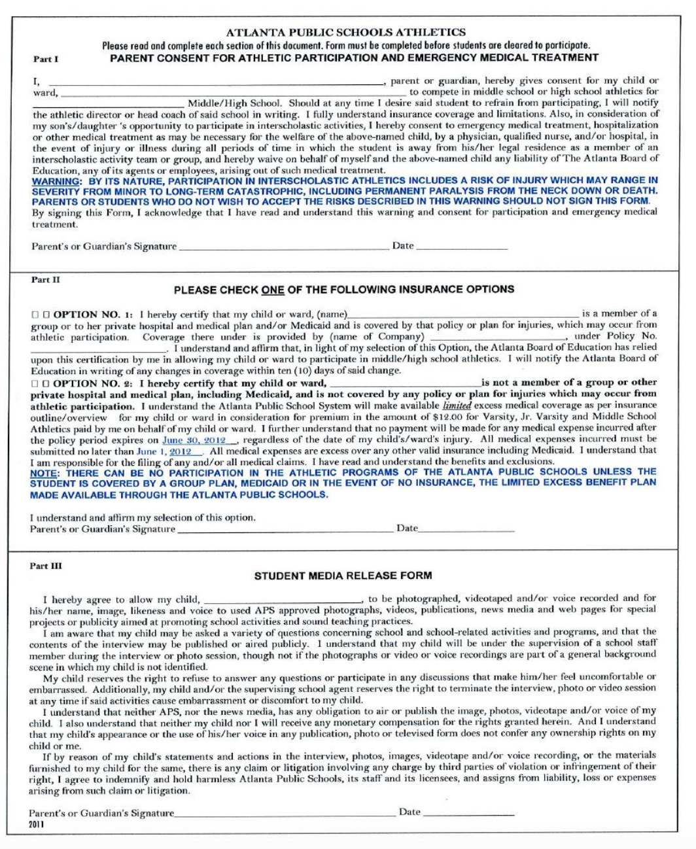

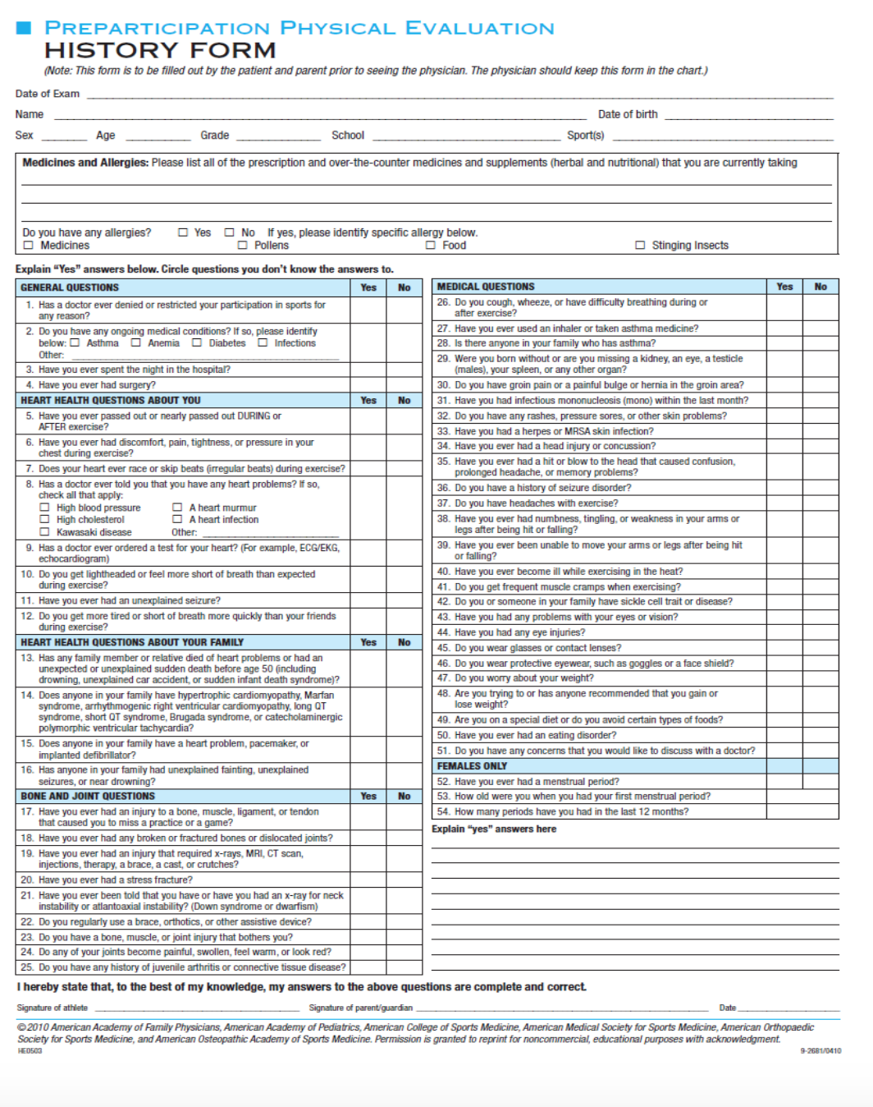

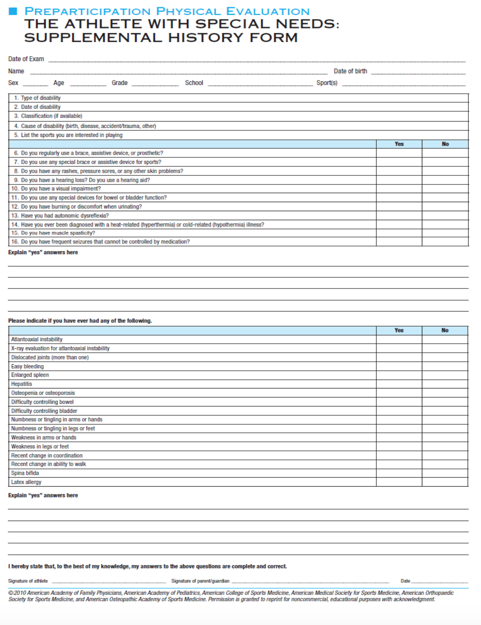

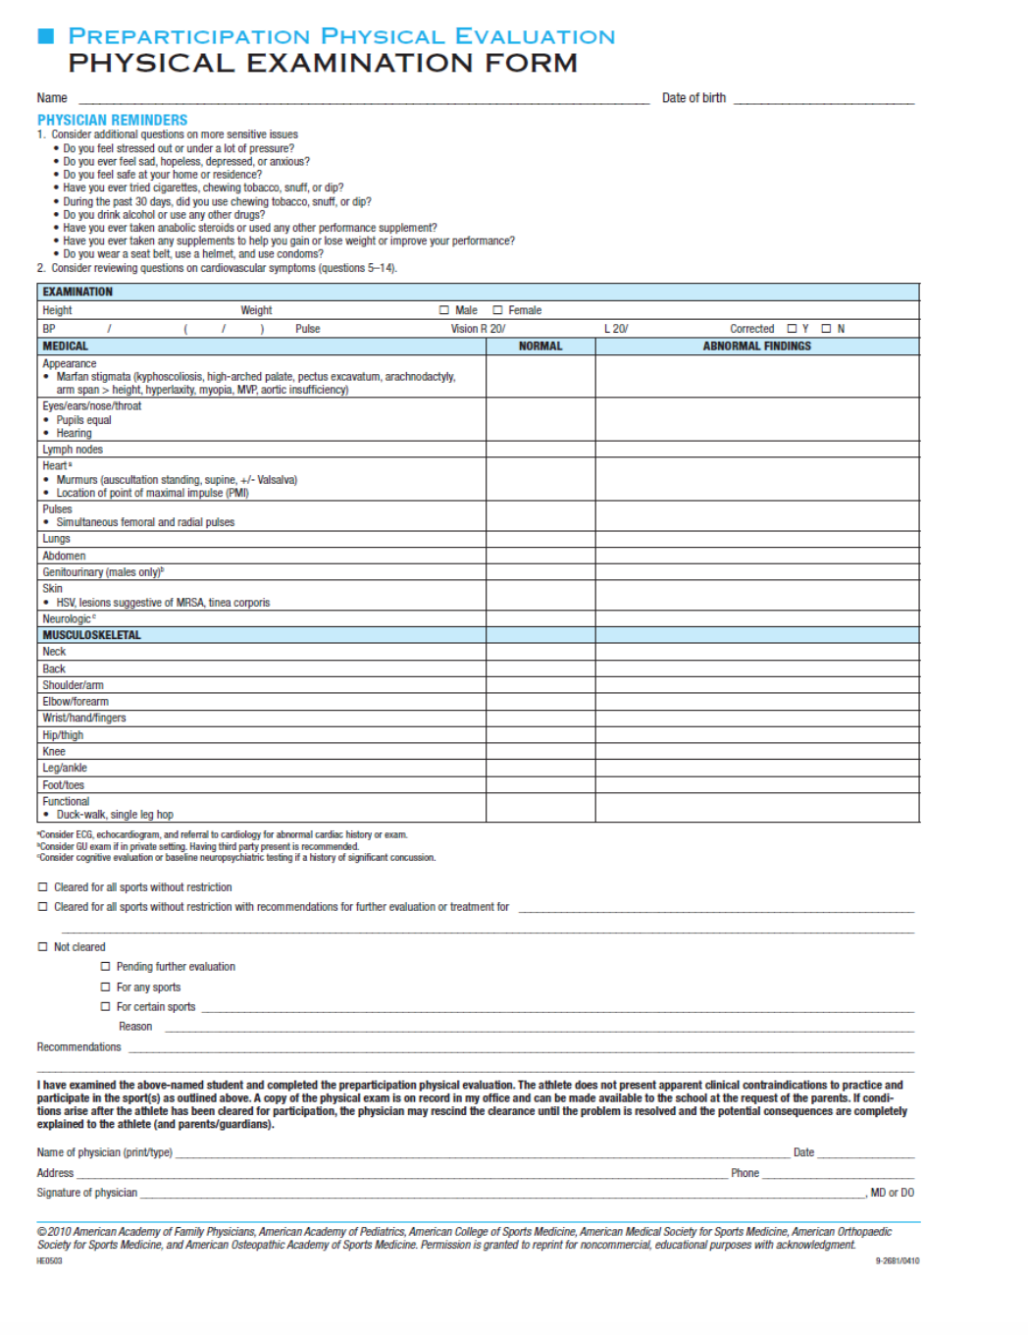

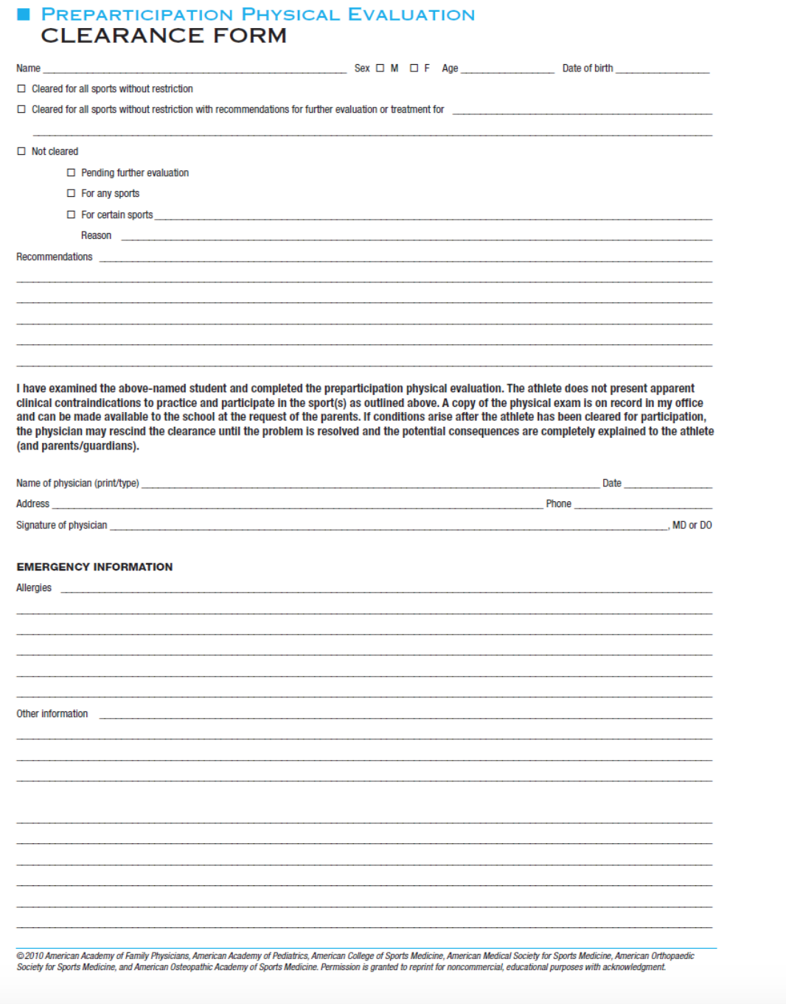

Appendix B

